# RESUME

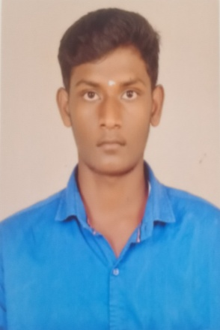

**DINESH KUMAR P**

4/149,Seval patty , Marungapuri(TK),Trichy(DT)-621314,India

<mailto:dineshkumarperumal7@gmail.com>

<http://www.linkedin.com/in/dinesh-kumar-p-6baa6024b>

6385290024

CAREER OBJECTIVES

A motivated individual with in-depth knowledge of coding languages and development tools, seeking a challenging position in an organization where I can use my talents and skills to grow and expand myself as well as grow an organization.

EDUCATIONAL PROFILE

**SSLC**

S R Vidhyalaya, Matriculation, Hr, Sec, School, Ayyanarpuram

Completed 10th standard with 79.8%

**HIGHER SECONDARY**

S R Vidhyalaya, Matriculation, Hr, Sec, School, Ayyanarpuram

Completed 12th standard with 85.34%

**B.E AUTOMOBILE ENGINEERING**

Kongu engineering college, Perundurai

CGPA 8.02 (Upto 2nd semester)

CO- CURRICULAR ACTIVITITES

**PAPER PRESENTATION**

I presented a paper on the topic of “**Utilization of LIOH from Spent Lithium batteries to enhance biodiesel synthesis”** in EXODIA 2022

**WORK SHOP**

Completed a one day workshop on ”**International workshop on electric and hybrid vehicle”,** Conducted by TOP ENGINEERS at IIT Madras Research park 01.10.20022

Attended 2 days workshop on Bicycle Design towards Bicycle Design Competition 2022 conducted by SAEINDIA SOUTHERN SECTION

AREA OF INTEREST

* Web Developer

SKILL SET

* C Programming

MEMBER SHIP

HOBBIES

HOBBIES

**Executive Member**  in Coding club

STRENGTH AND WEAKNESS

D WEAKNESS

STRENGTH

* Self Confidence

WEAKNESSS

HOBBIES

HOBBIES

* Short temper

PROFILE

* Ansysis

DOB : 17- JAN -2004

AGE : 19

FATHER’S NAME : PERUMAL.A

OCCUPATION : FARMER

MOTHER’S NAME : VELLAIAMMAL.P

OCCUPATION : HOUSE WIFE

NATIONALITY : INDIAN

LANGUAGE KNOWN : TAMIL,ENGLISH

DECLARATION

I (DINESH KUMAR) here by declaration that all the above information are true to the best of my knowledge

HOBBIES

HOBBIES